- “Team #: 15(5542)”

- “Members:”
1. Sidrah Junaid
2. Yeruva, Vijaya Kumari
3. Saria Goudarzvand

- “Project Goal and Objectives”
- “Motivation:”
The Main motivation of this application is to categorize the users mood, activities and food with twitter API. Firstly, we categorize the people in a city according to their activities, food, emotional things. It can lead us to having two different groups in terms of having a healthy life style or not. user then log in to this application via his or her profile in twitter to see in which category she will be grouped. with that, we can find the most similar adults that are as the same in emotional aspects, food and activities.

- “Significance/Uniqueness:”
The other Apps has nothing to do with the tracking of emotional aspect and also food. They just track the activities a person do then notifying the user at the right time about those activities as walking, having lunch. There is also another App that works just based on the profile a user make. It may not have accurate result as the users make their profile when they are in good mood and think positively.

- “Objectives:”
To provide a good approach to matching people that are as the same in the emotional aspects, activities and food.

- “System Features:”
The system will use Twitter API to extract some knowledge of a person. These data may be image data, data about the activities a person usually do and the text she or he shares through the social networks. The combination of these data will be used to categorize one in a special group.

- “Challenges:”
The most important issue in this project is combining the result of each step for using in the following steps.

- “Project Planning :”
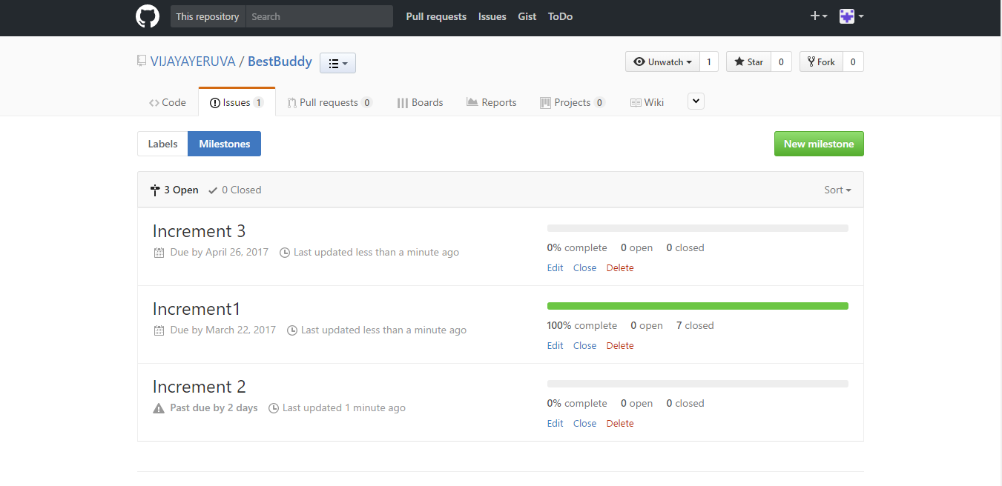
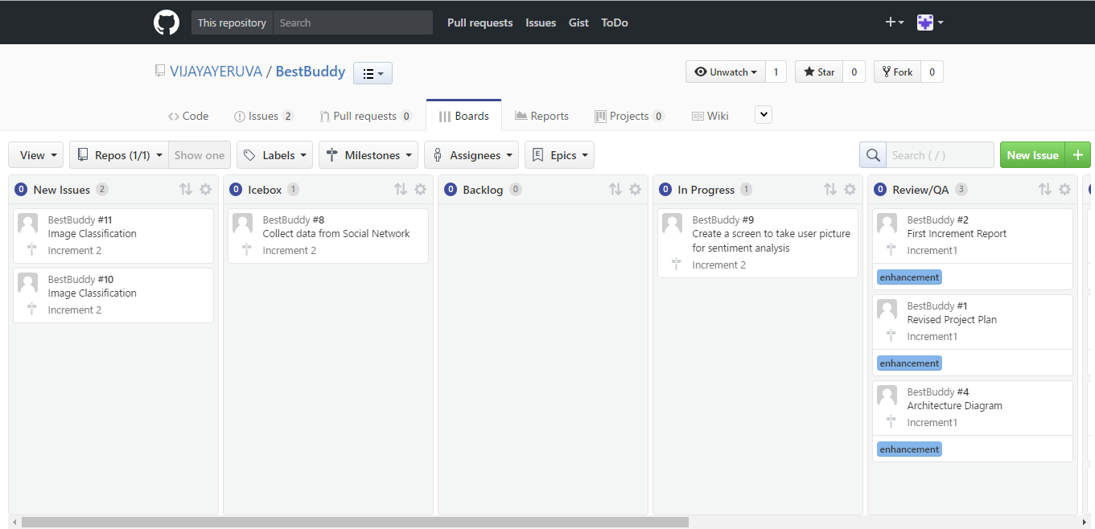
- “First Increment Report:”
In this increment we have completed the interface of speech recognition .The user voice would be an input for the application and then it will show the text as an output.
- “Wireframes of First Increment:”
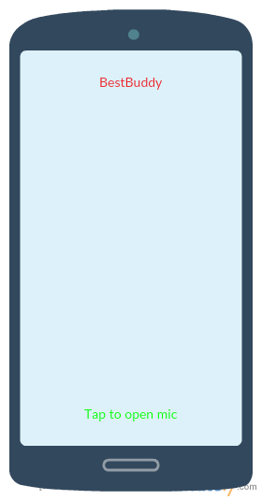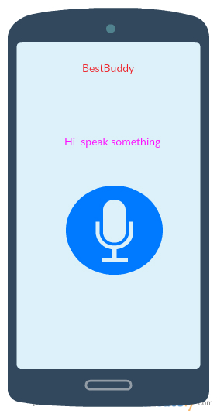
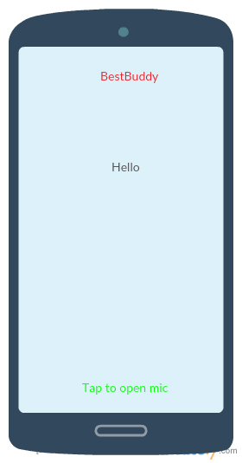

- “Second Increment:”
Social Network data collection and implementation of face and emotion recognition

- “Project Management “
- “Work Completed :”
- “Description In Increment1:”
We have developed speech recognition required for the project.
- “Responsibility:”
(1) Draw layouts on board All
(2) Team meeting All
(3) Draw wireframes for user interfaces All
(4) Develop user interfaces for the wireframes All
- “Time taken” 20 hours
- “Contribution:”
Equal contributions from all the group members

- “Related Work”
- “Projects done by others (include the URLs in Bibliography): NA”

- “Bibliography”
- Voice to text - Cloud Speech API by Google (https://cloud.google.com/speech/)
- Voice to text – Alchemy API (https://speech-to-text-demo.mybluemix.net/)
- Text to sentiment – Cloud Natural Language API by Google (https://cloud.google.com/natural-language/)
- Text to sentiment – Alchemy API (https://www.ibm.com/watson/developercloud/tone-analyzer.html)
- Similarity between text/documents - Find Similar (https://dev.havenondemand.com/apis/findsimilar#overview)

Demo of Similar Projects
- https://youtu.be/8PvDgS6vCkQ
- https://www.youtube.com/watch?v=VazSEtXHDcI

